## **CS 3750 - Challenge 7-1**

By: Levi Bernards, Hayden Blackmer, Natalie Mueller

## Stakeholders & Their Needed Functionality:

**Goal:** With the implementation of this system, it will be possible to document and manage reservations for the HAFB FamCamp. This will include updating information about the Park, creating accounts and creating reservations in a way that park capacity will be managed and won’t cause overbooking of the camp.

**Guests:**

* Create an account
* Login/Logout
* View Prices/Availability
* Create Reservation
* View General Information

**Employees:**

* Everything a Guest can do
* View/Modify Reservations
* View all availability by day
* Check People In/Out
* Refund/Process Payments

**Manager (Scott):**

* Everything an Employee can do
* Add/Remove/Update Employees
* Add/Remove/Update Sites & Rates

**IT Worker (Keith):**

* Update General Information (Policies, hours, etc)

## 

## **Entity-Relationship Diagram**

## 

## **Use Case List:**

1. Create/Update Guest Account: An unregistered user will be able to create an account, including declaring their military affiliation in order to make reservations. Registered Users will also be able to access the same page to change personal information as needed.
2. View Availability: A logged-in user will be able to enter in a specific arrival date, number of nights for their visit and the size of their RV. This information will determine whether there is still availability for those specific dates and, if so, allow the user to create a reservation.
3. Create/View/Update Reservations: A logged-in user will be able to create a reservation, including submitting payment for it. Additionally, an Admin will be able to make changes to reservations as requested by pending guests.
4. Process Payment/Refund: A logged-in user will be able to pay for a new reservation. Additionally, an Admin will be able to process payments for violations of policies/extra fees as well as process refunds for cancellations/overcharges.
5. Update Website Information: An IT-personnel/Admin will be able to make changes to the general FamCamp information.
6. Check Guests In/Out: An Admin will be able to track the status of guests, checking them in/out throughout their reservation.
7. Add/Update/Delete Employee Information: An Admin can create an Employee Record, and make changes to their log-in and other personal information.
8. Add/Update/Delete Site Information: An Admin can change information (rate, size, description, etc) for the differing sites offered in the FamCamp.

## **Use Case Diagram**

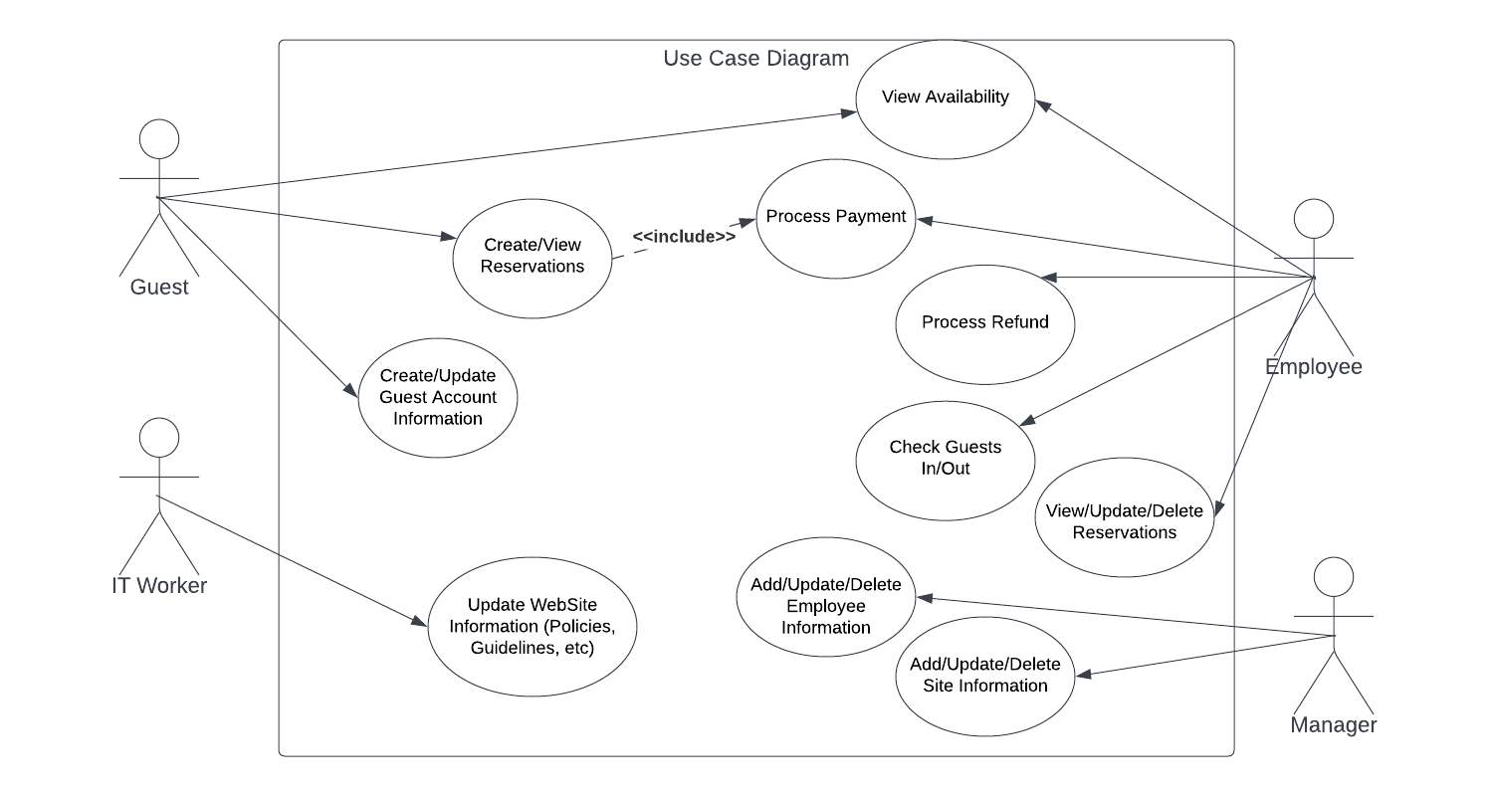

## 

## **Use Case Activity Diagrams:**

1. Create/Update Guest Account:

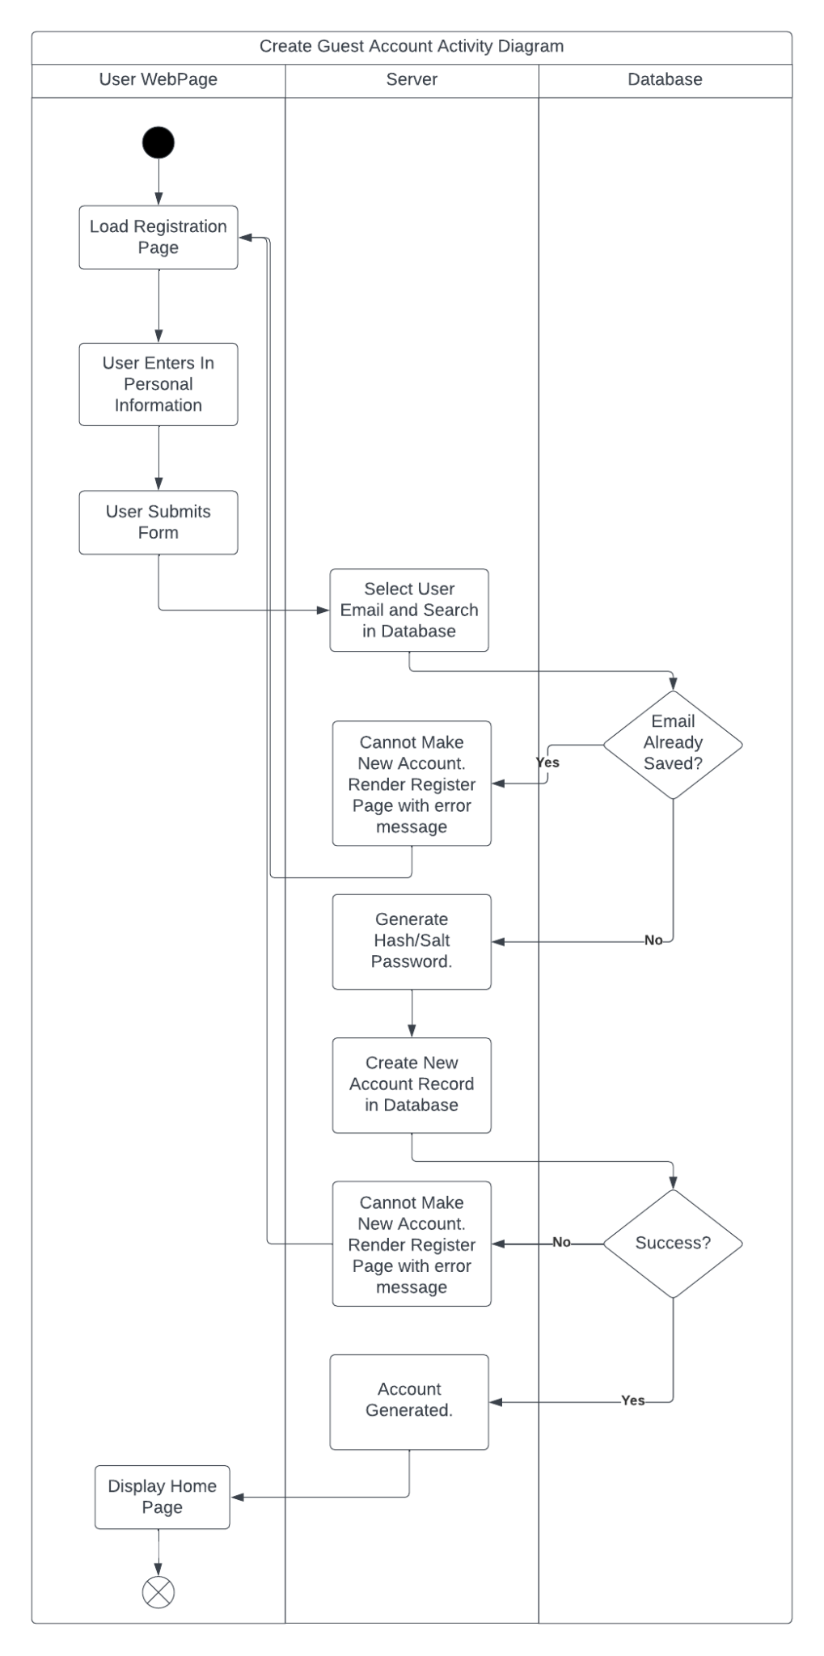

1. View Availability:

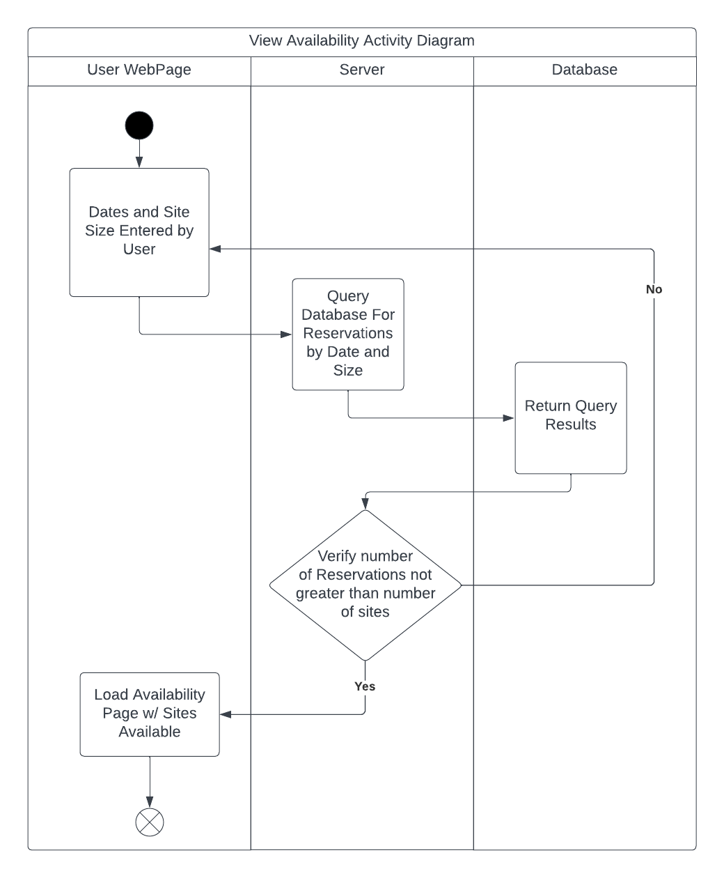

1. Create/View/Update Reservations:

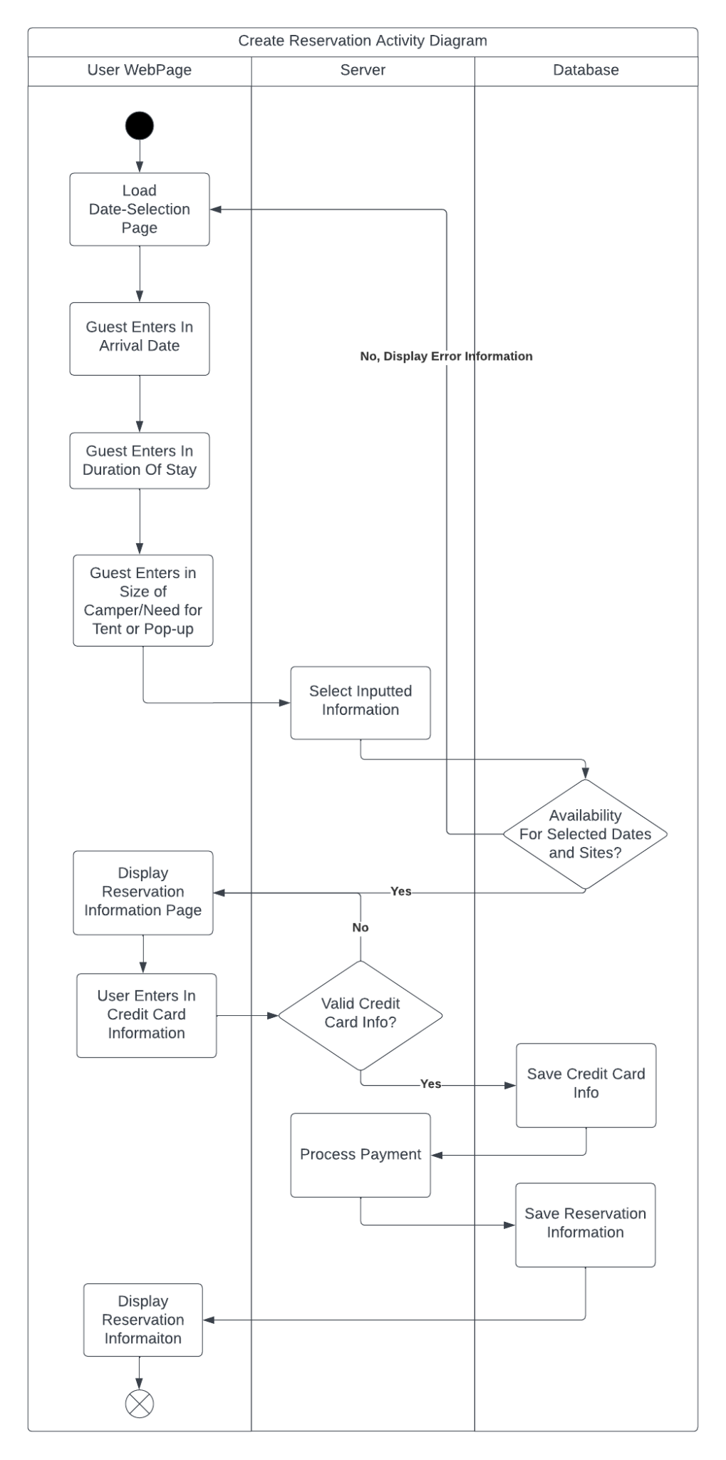

1. Process Payment/Refund: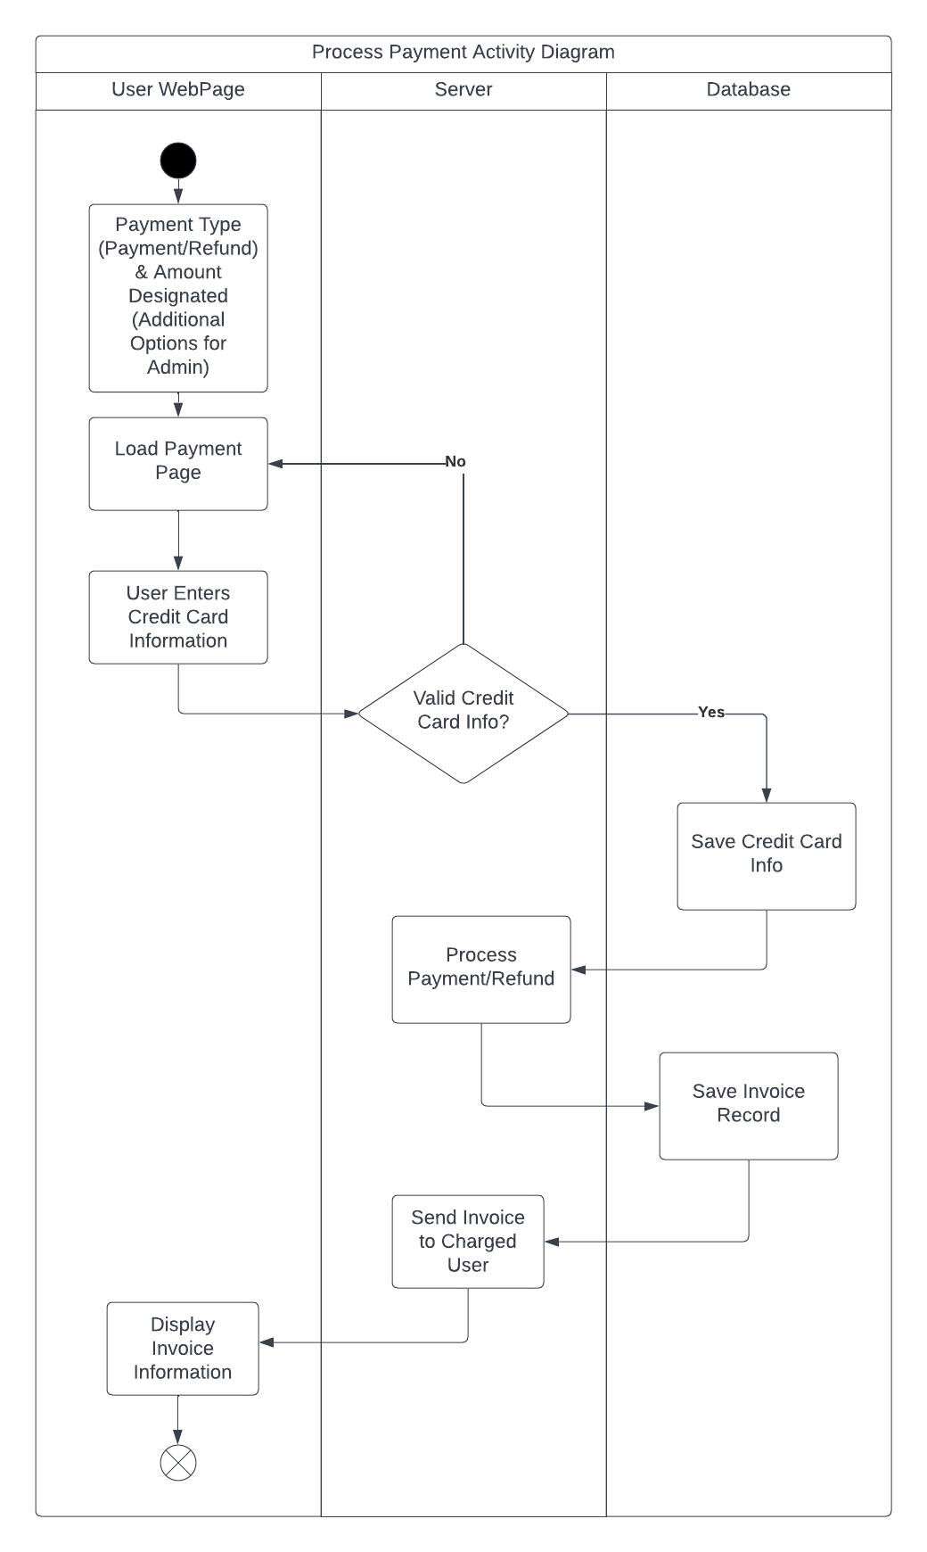
2. Update Website Information

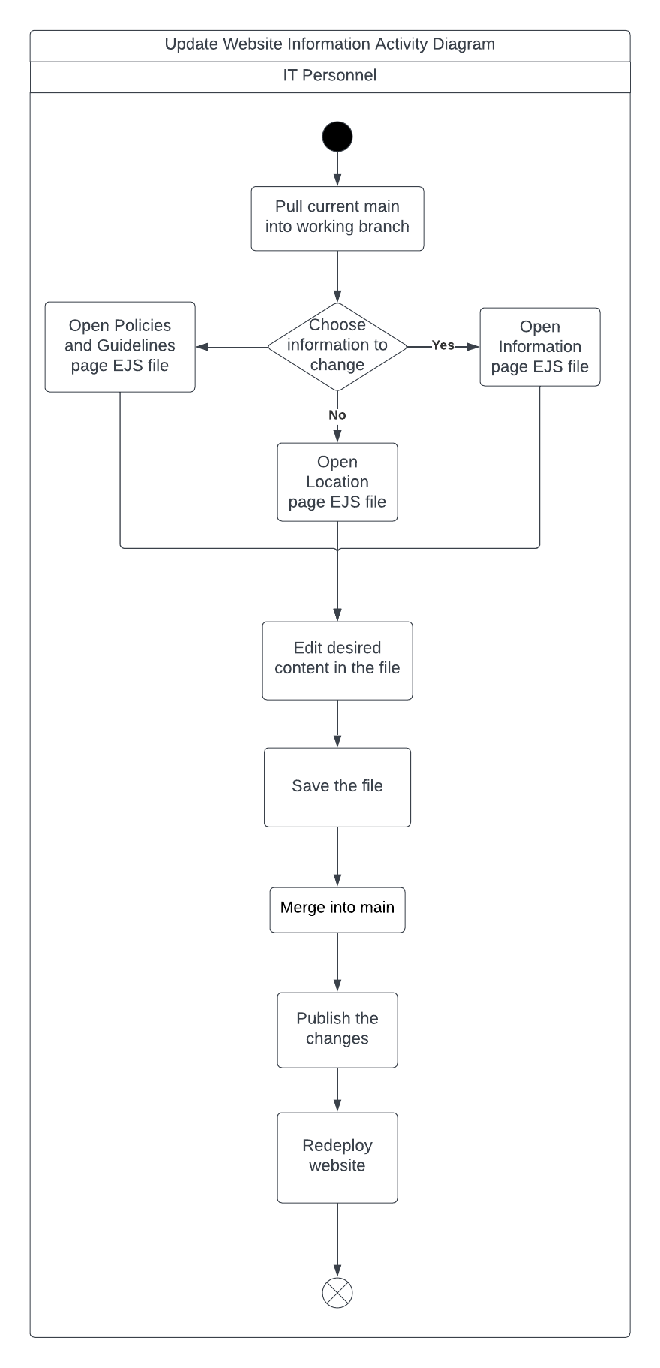

1. Check Guests In/Out

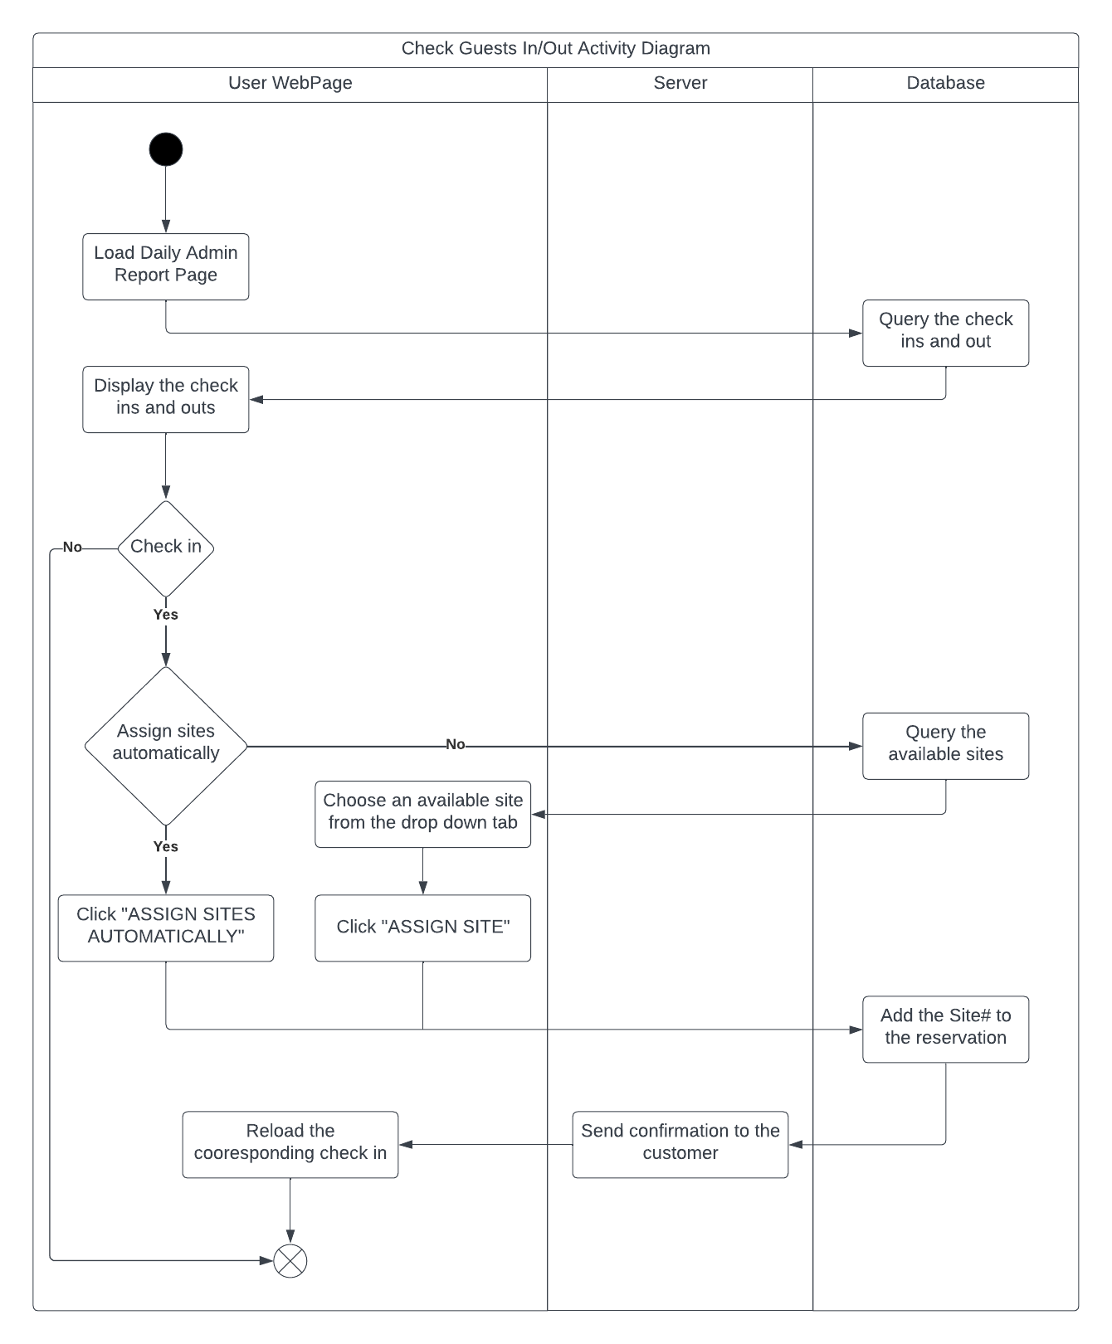

1. Add/Update/Delete Employee Information

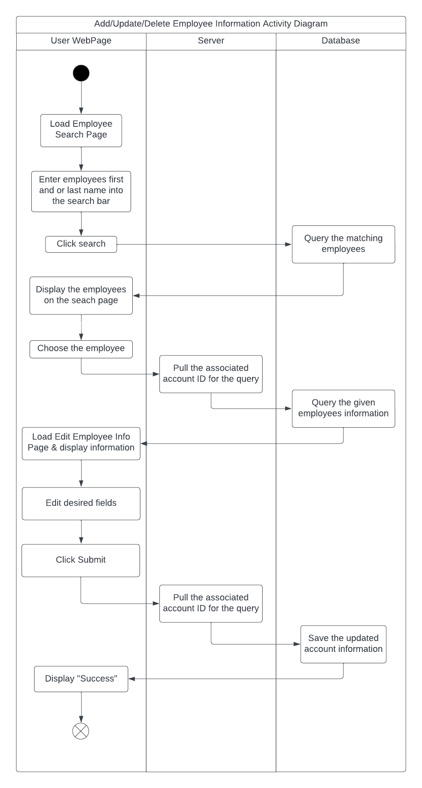

1. Add/Update/Delete Site Information

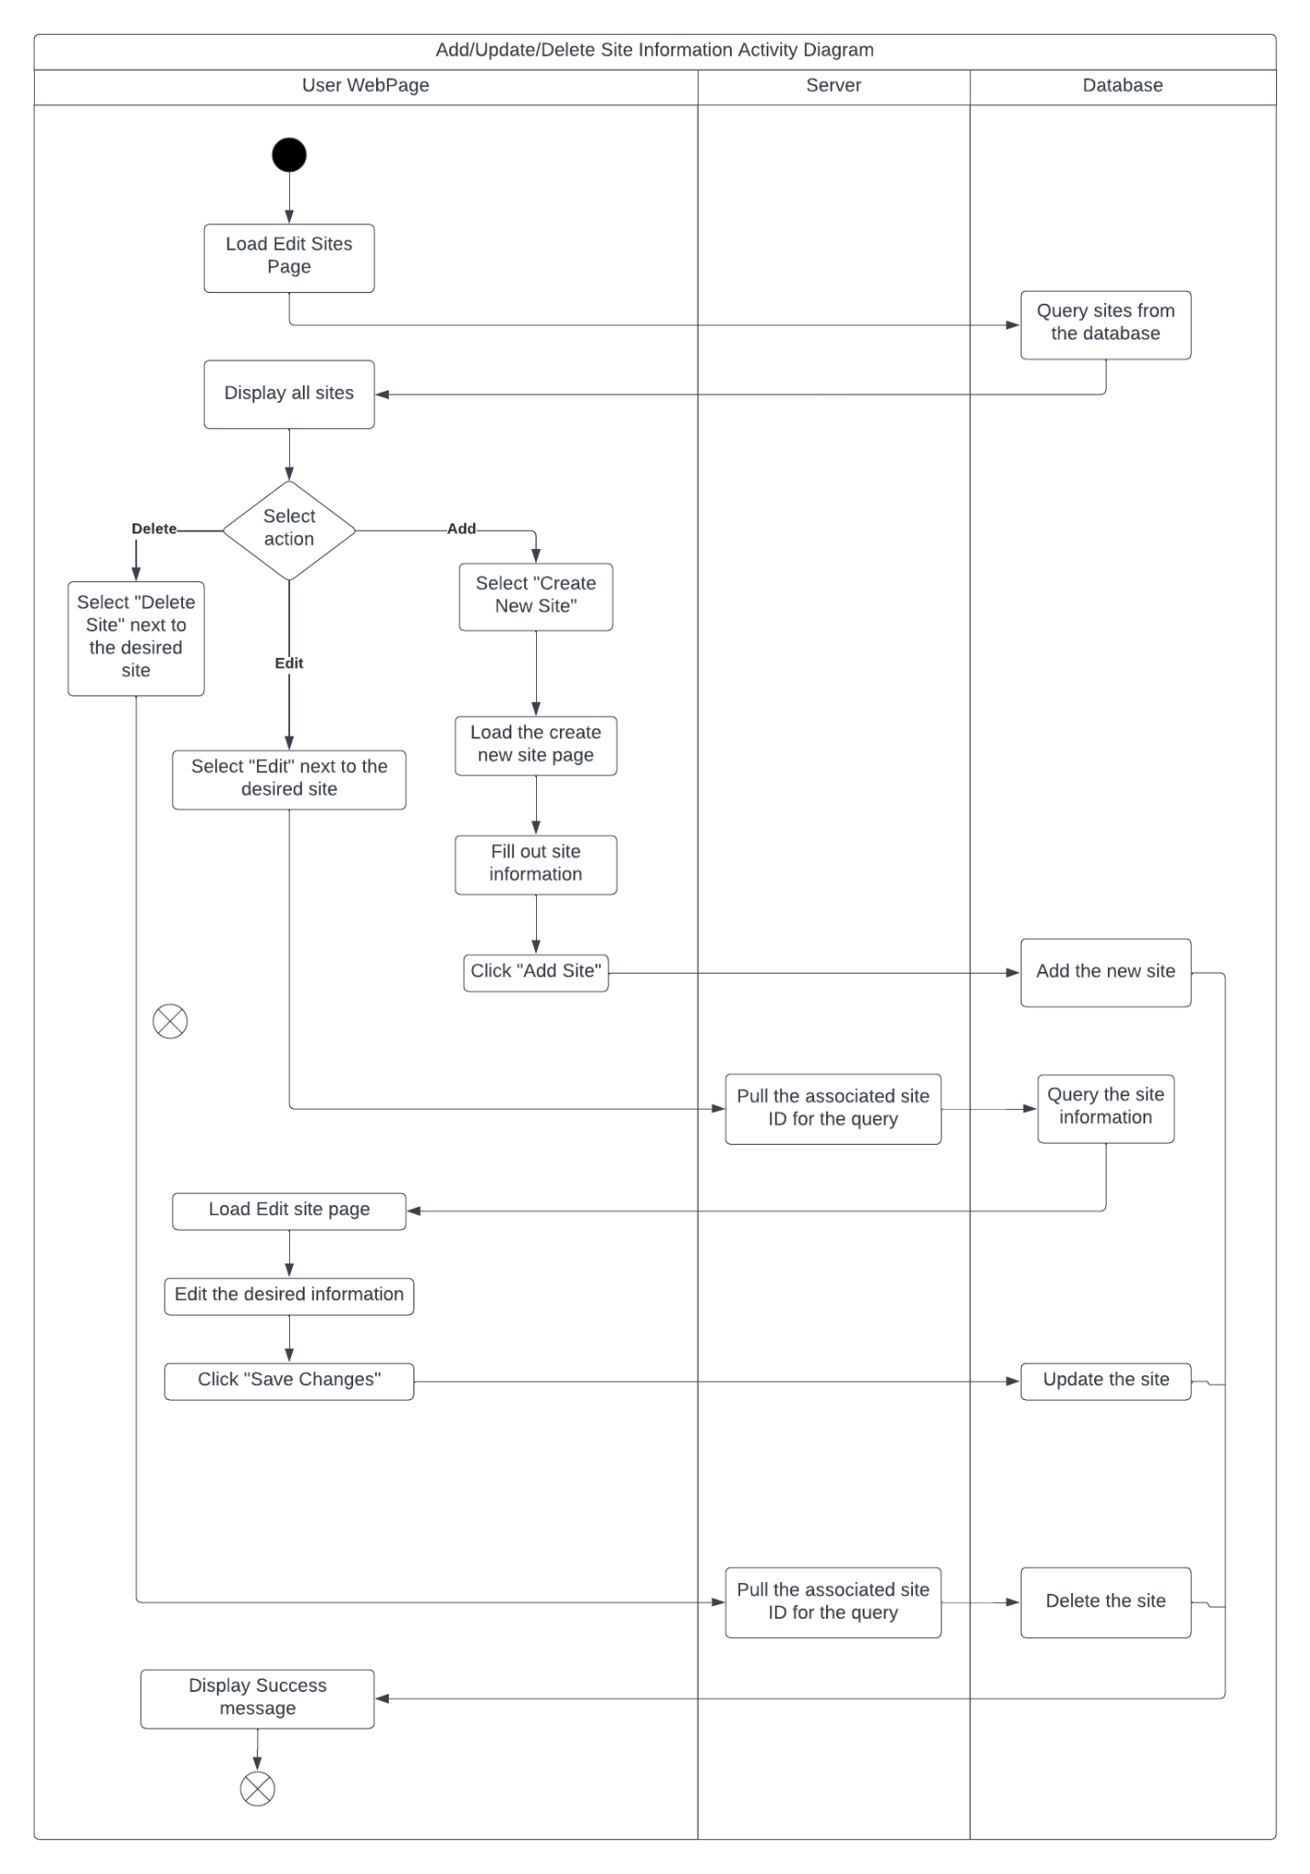

## 

## **User Interface Mock-Ups:**

1. Home page

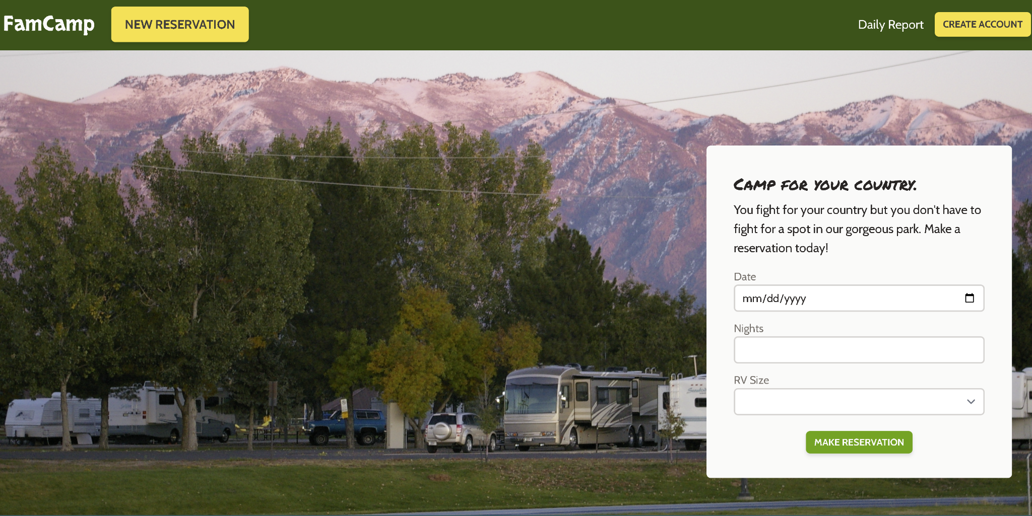

1. Register

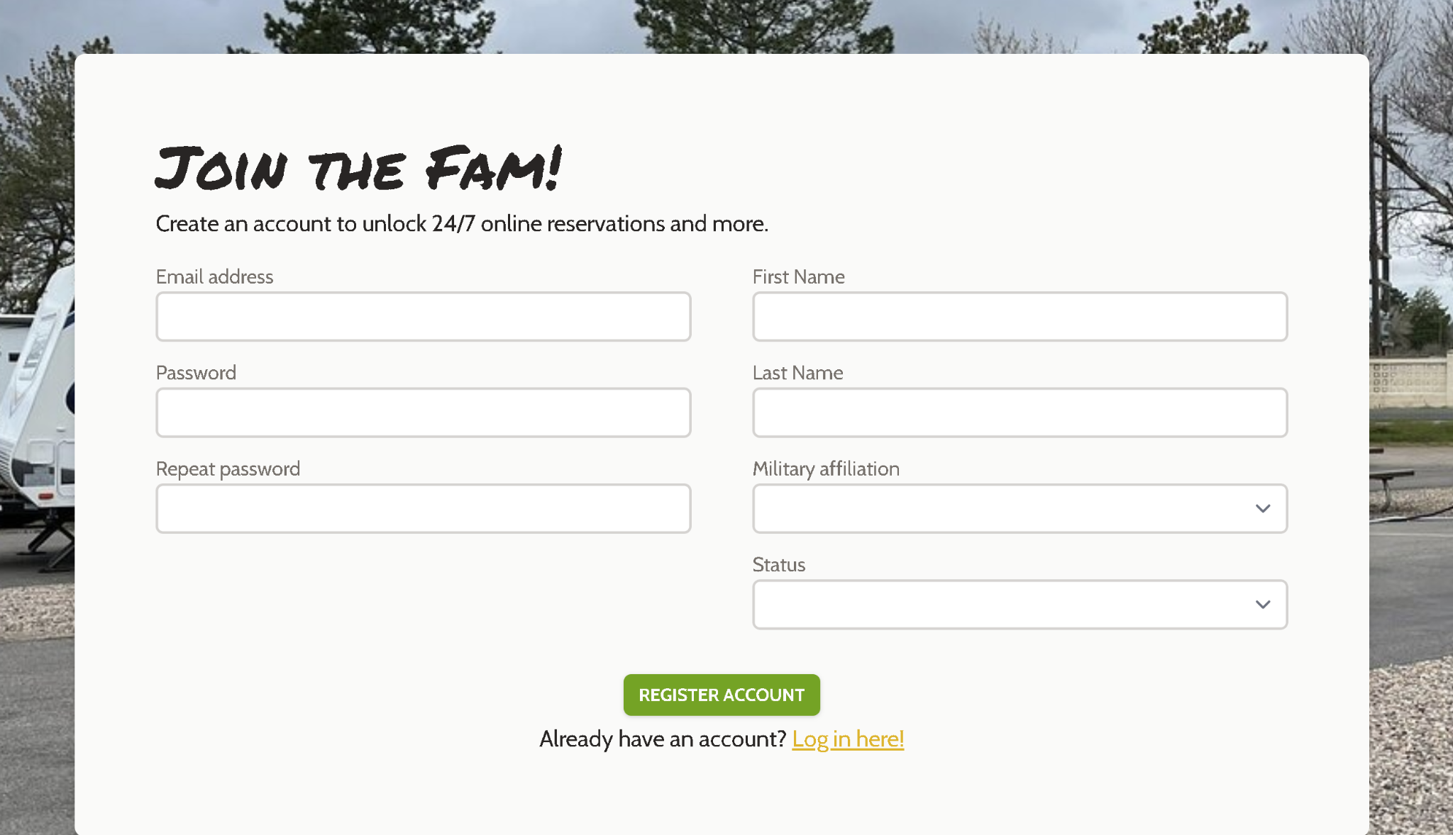

1. Login

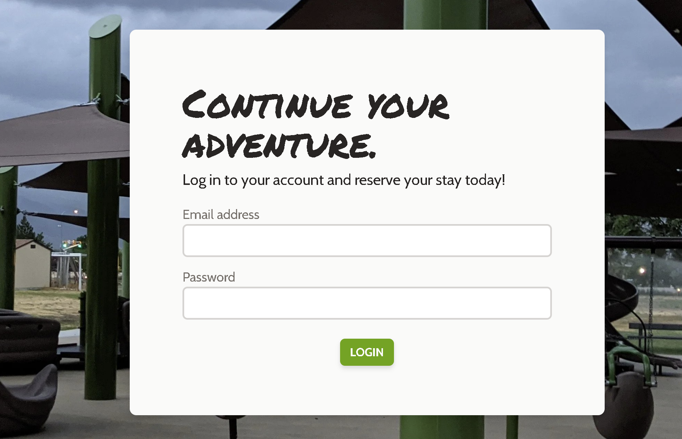

1. User profile

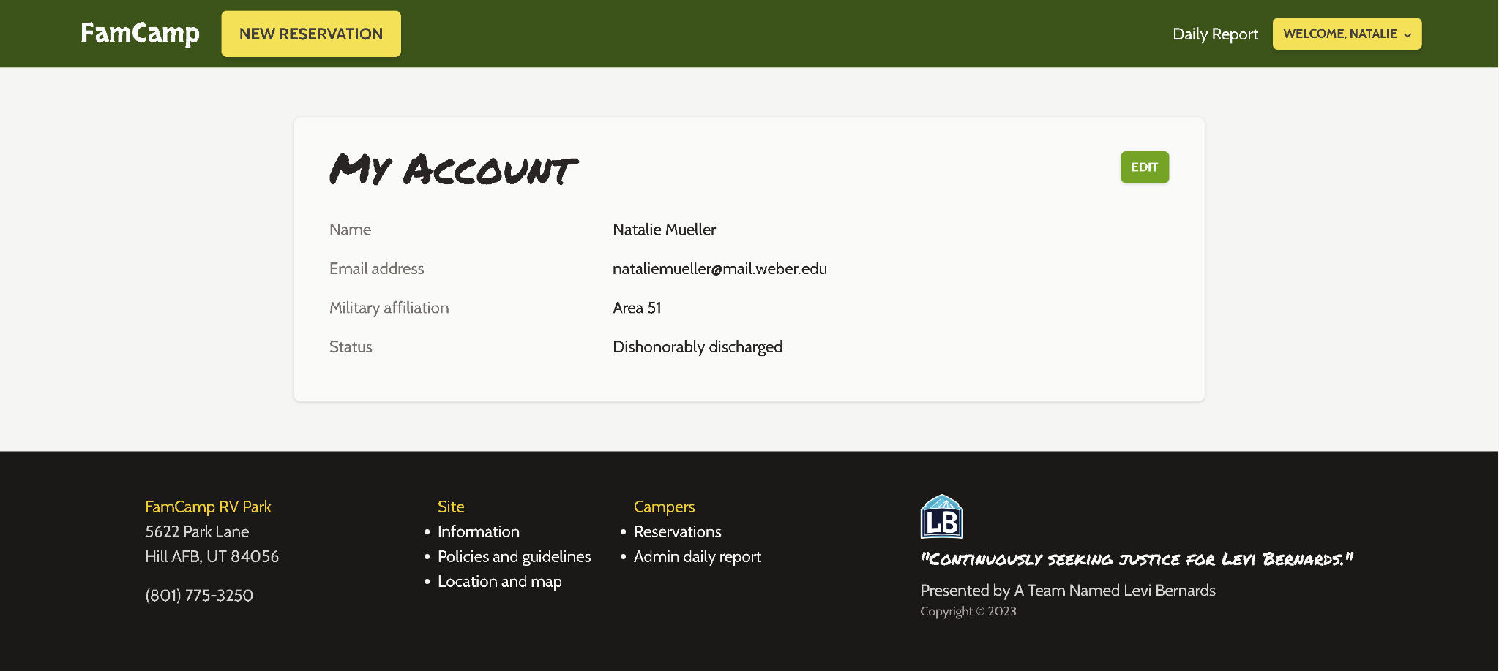

1. Reservation form

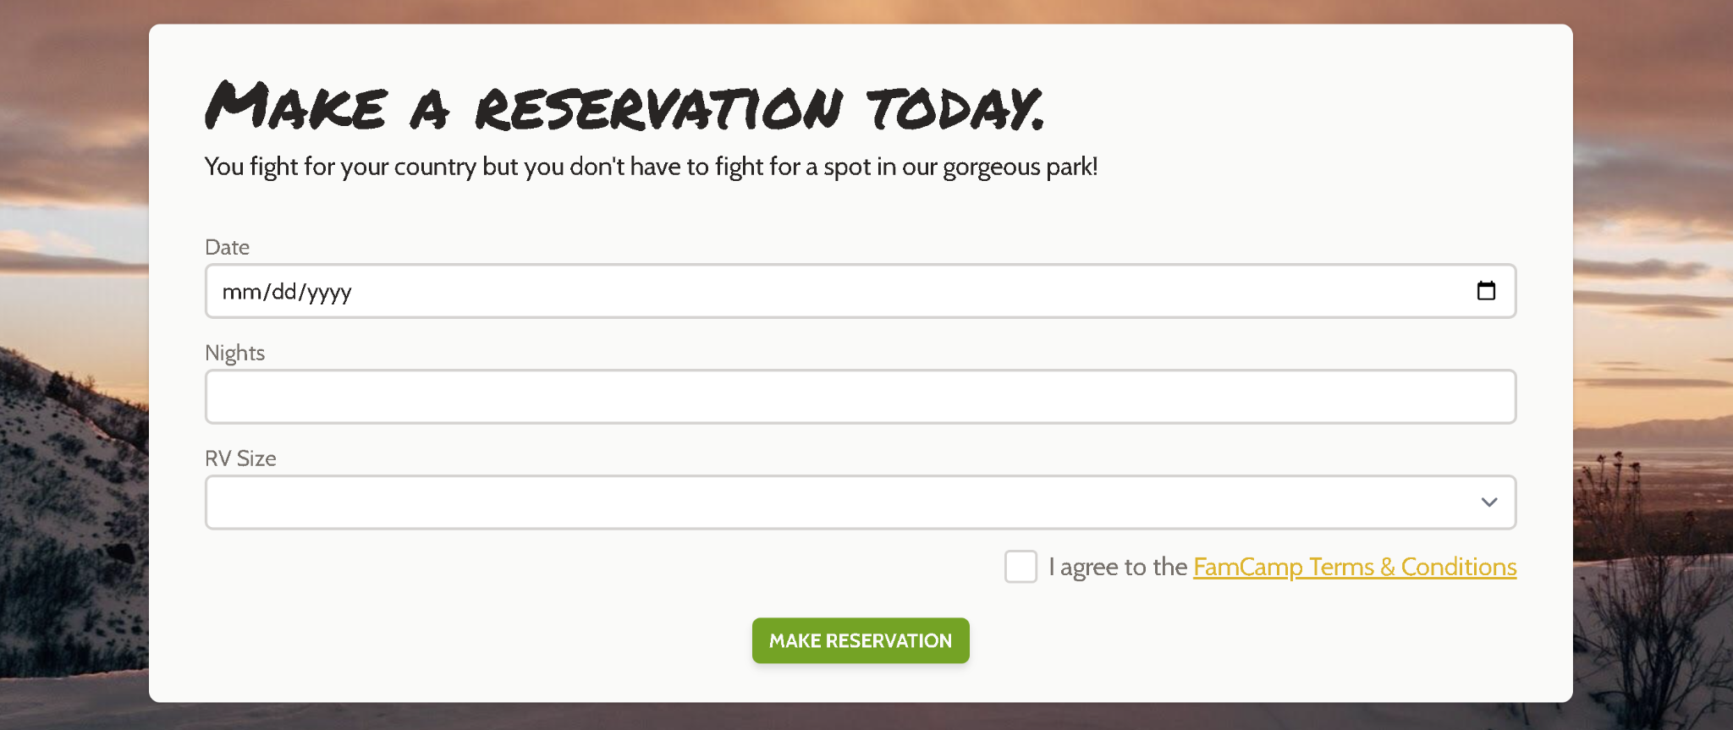

1. Reservation confirmation

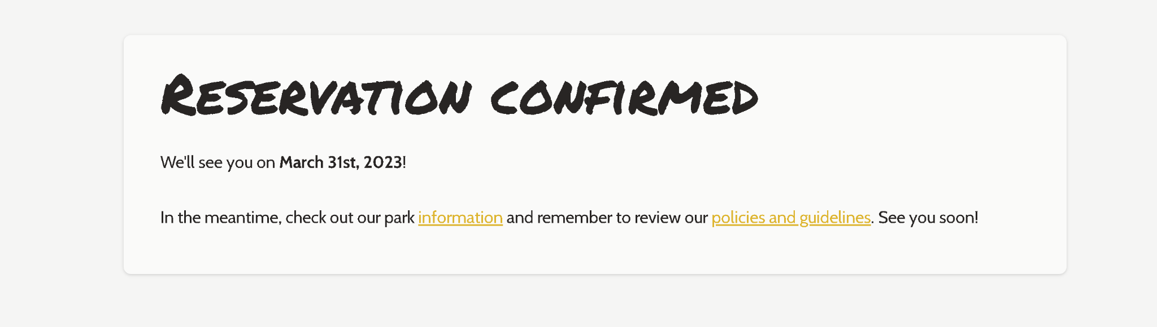

1. User reservation history

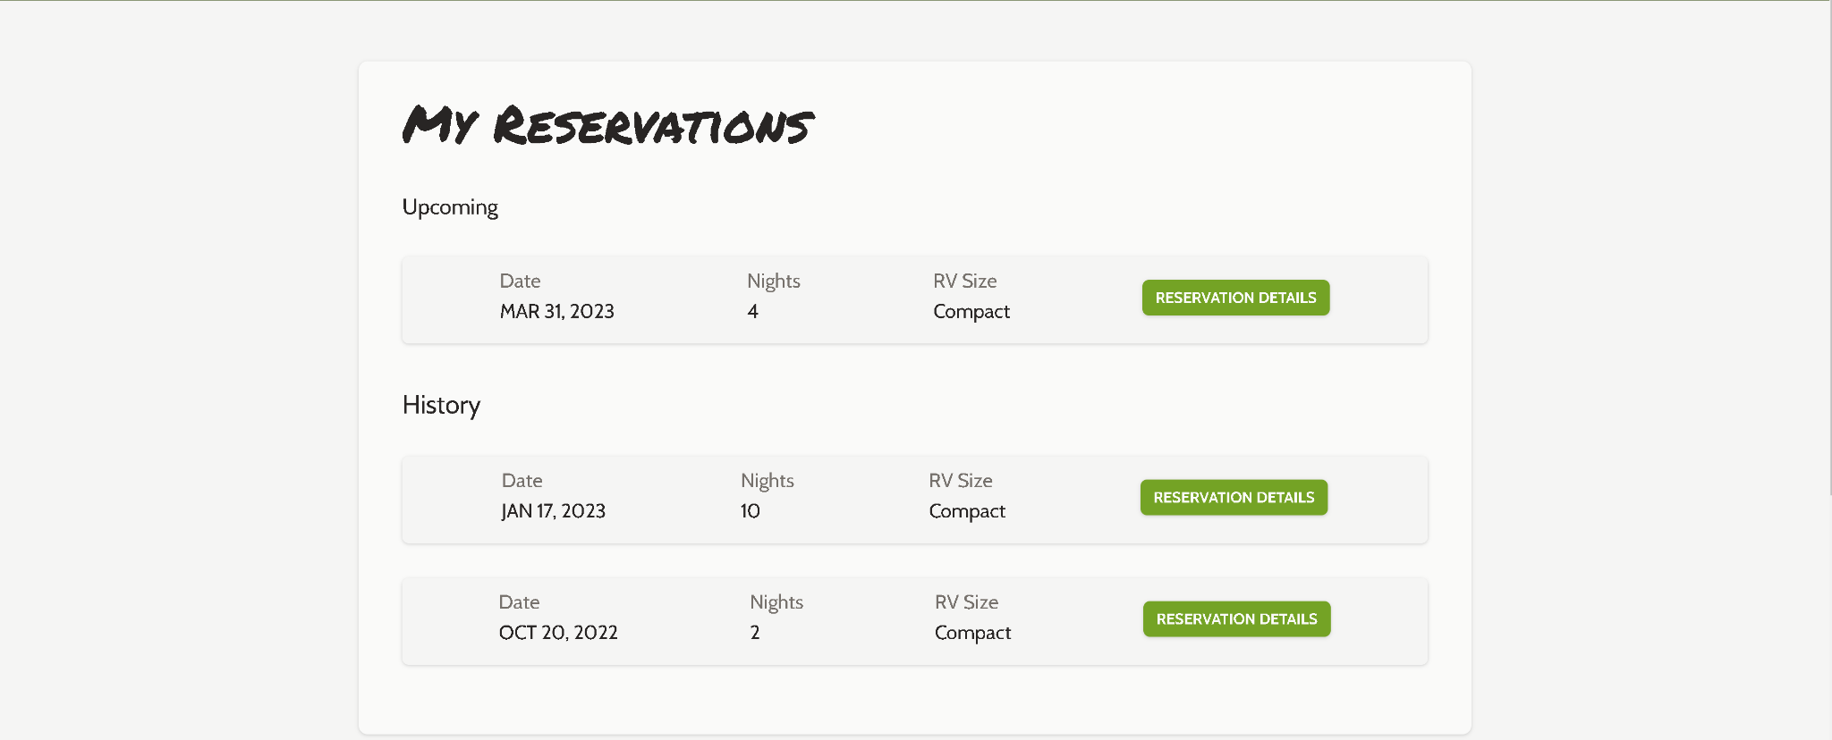

1. Reservation details

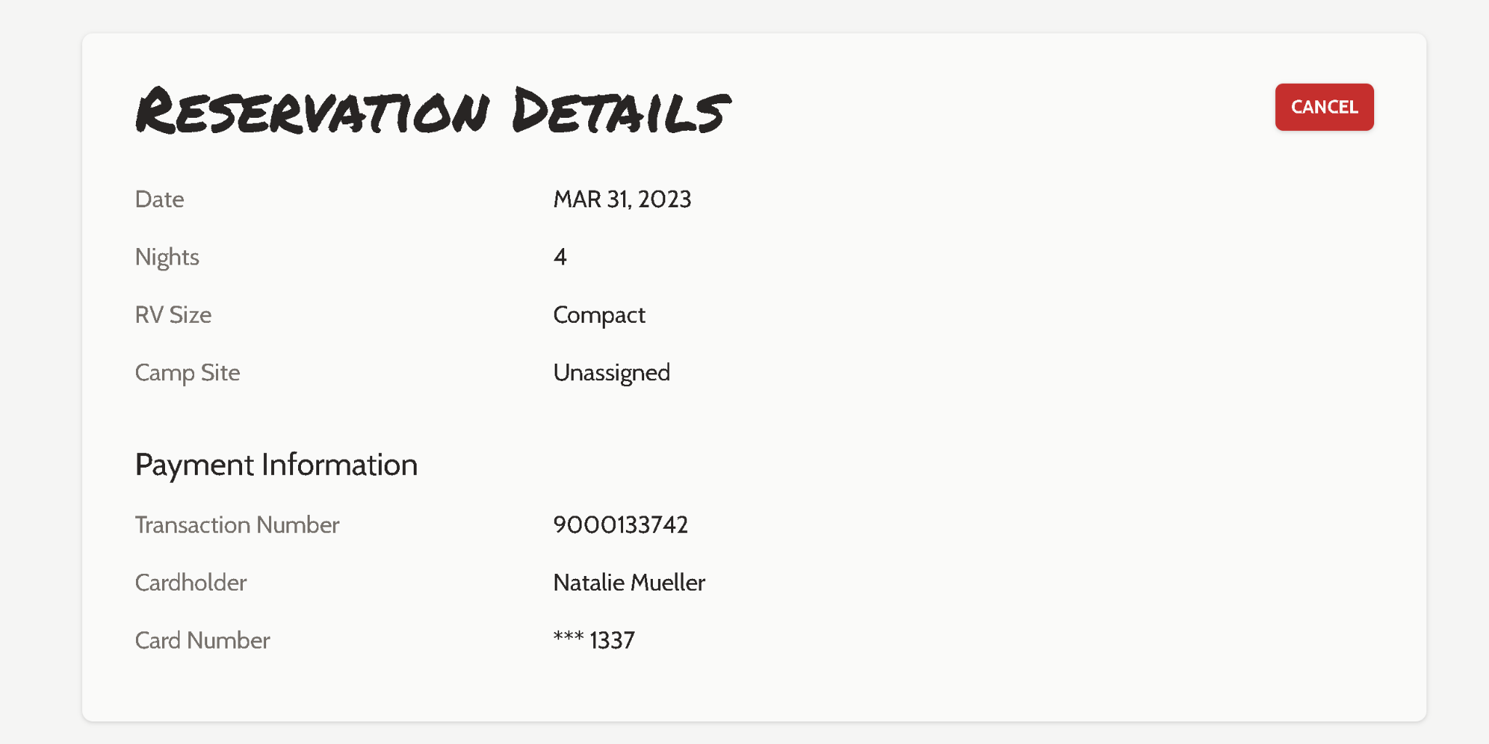

1. Admin daily report

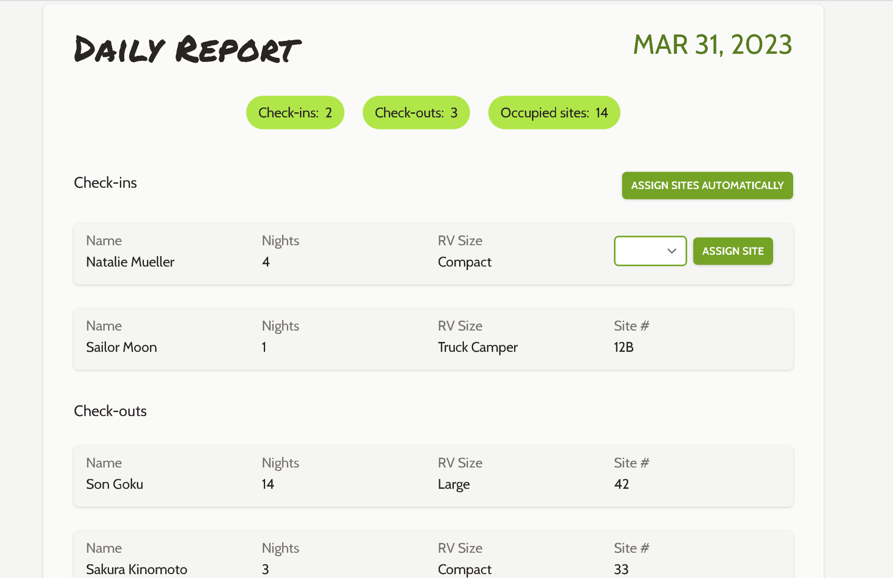

1. FamCamp Information/location/guidelines

